API Security Risk Analysis Report
Prepared By: Durga R
Task 3 – API Security Analysis
Date: [09/03/2026]

1. Introduction
Modern applications rely heavily on APIs to power mobile apps, SaaS platforms, dashboards, and integrations. While APIs improve efficiency, they can also expose sensitive data if not designed securely.
This report analyzes publicly available API endpoints from JSONPlaceholder (a safe test API) to identify potential security risks. The purpose is to demonstrate how insecure API design can affect business data, and provide recommendations to reduce risk.

2. Tools Used
- Browser (Google Chrome): To send GET requests and view API responses.
- JSONPlaceholder Public API: Demo API for testing endpoints.
- MS Word: Documenting the findings in a professional report.

3. APIs Tested
Method | ENDPOINT | PURPOSE
GET | /users | Retrieve user information
GET | /posts | Retrieve posts data
GET | /comments | Retrieve comments data
GET | /albums | Retrieve album data

4. Testing Methodology
- Identify publicly available API endpoints.
- Access the endpoints using a browser.
- Inspect the API responses for sensitive information.
- Check if authentication is required.
- Identify potential security risks (data exposure, open endpoints, missing controls).
- Document findings in a business-friendly manner.
Note: Only safe, read-only GET requests were performed. No attacks, DoS, or data modification were attempted.

5. Security Findings

5.1 /users Endpoint
Observation:
The /users endpoint provides detailed user information, including name, username, email, phone, address, and company details, without requiring authentication.
Risk:
- Open API Endpoint
- Excessive Data Exposure
Business Impact:
- Personal data could be accessed by unauthorized parties.
- Potential misuse of sensitive customer information.
Recommendation:
- Implement authentication (API keys, OAuth tokens).
- Limit returned fields to only necessary data.
Screenshot: Figure1: users_api.png

5.2 /posts Endpoint
Observation:
The /posts endpoint exposes all posts publicly with no login required. Each post includes userId, post id, title, and body.
Risk:
- Open API Endpoint
Business Impact:
- Anyone can view internal posts, potentially revealing business content.
Recommendation:
- Apply authentication if post data is sensitive.
- Consider access control for production APIs.
Screenshot: Figure2: posts_api.png

5.3 /comments Endpoint
Observation:
The /comments endpoint exposes comment data including user email addresses.
Risk:
- Sensitive Information Exposure
Business Impact:
- Email addresses can be used for spam or phishing campaigns.
Recommendation:
- Mask email addresses in responses.
- Implement authentication if email visibility is unnecessary.
Screenshot: Figure3: comments_api.png

5.4 /albums Endpoint (Optional / Screenshot 4)
Observation:
The /albums endpoint is publicly accessible without authentication.
Risk:
- Open API Endpoint
Business Impact:
- Unauthorized access to business-related album data.
Recommendation:
- Apply authentication or restrict data access based on user roles.
Screenshot: Figure4: albums_api.png

6. Risk Severity and Business Impact
VULNERABILITY/END POINT | RISK LEVEL | BUSINESS IMPACT | RECOMMENDATION
/users – Open endpoint | Medium | Attackers can access sensitive user data | Implement authentication and limit data exposure
/users – Excessive data exposure | Medium | Privacy violation, data misuse | Only return necessary fields
/comments – Exposed emails | Low | Emails could be collected for spam/phishing | Mask or restrict email fields
/posts – No rate limiting | Low | Unlimited requests could overload the system | Implement request rate limiting
/albums – Open endpoint | Low | Public access without control | Apply authentication if needed

7. Conclusion
The API security analysis identified several potential risks including:
- Open endpoints without authentication
- Excessive data exposure
- Email information visible publicly
- Lack of rate limiting
Business Impact: Sensitive information exposure may lead to privacy concerns, potential misuse, and reputational risks.
Recommendation: Implement proper authentication, access control, rate limiting, and limit sensitive data exposure to reduce the risk to business systems.

- Screenshots

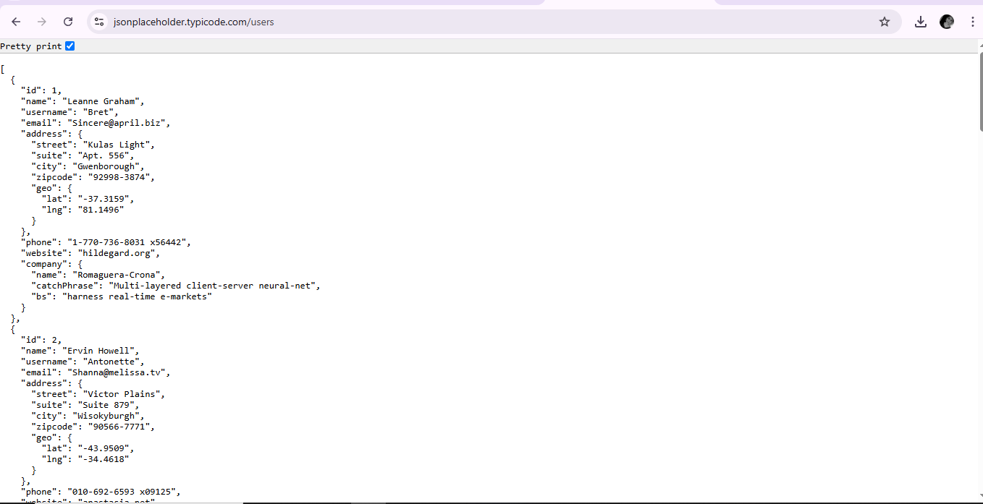

Figure 1: /users API response showing user data including email and phone.

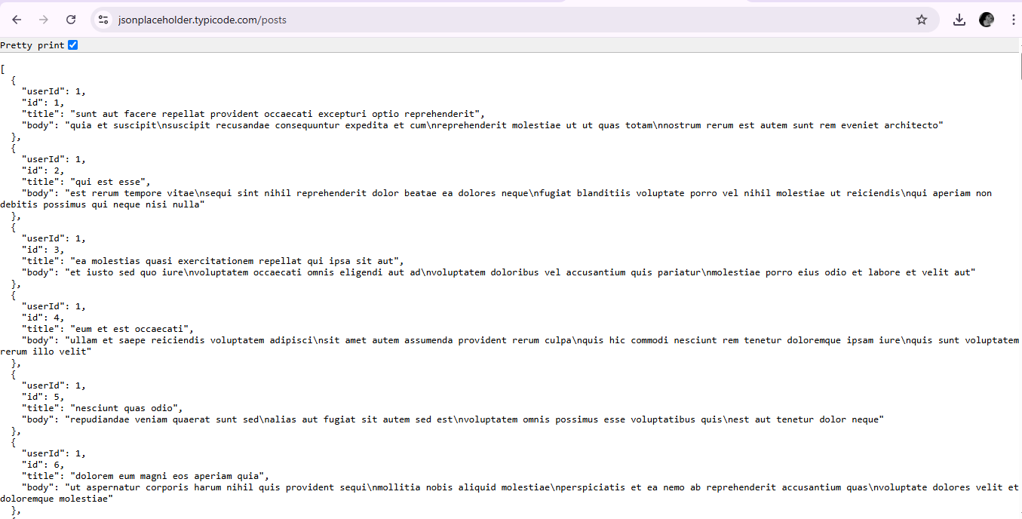

Figure 2: /posts API response showing publicly accessible posts.

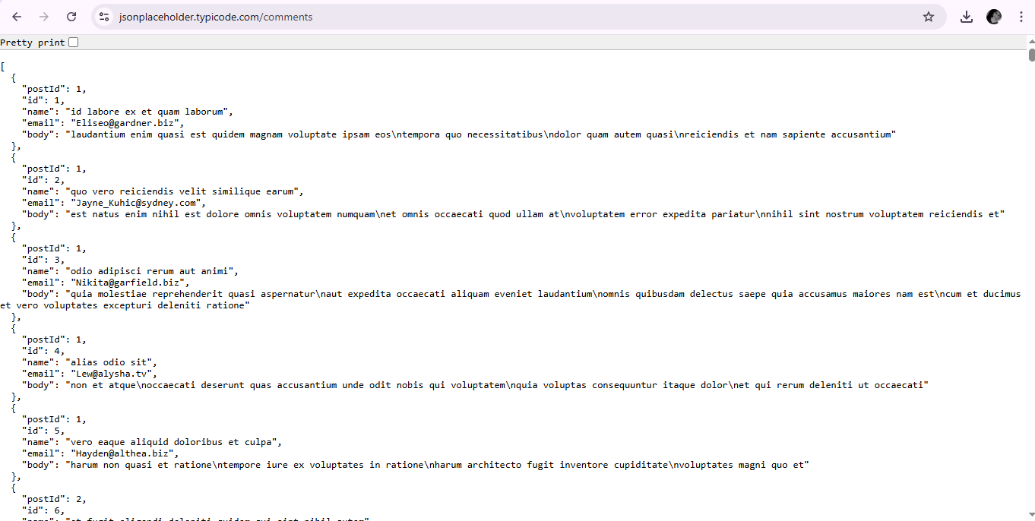Figure 3: /comments API response showing exposed email addresses.

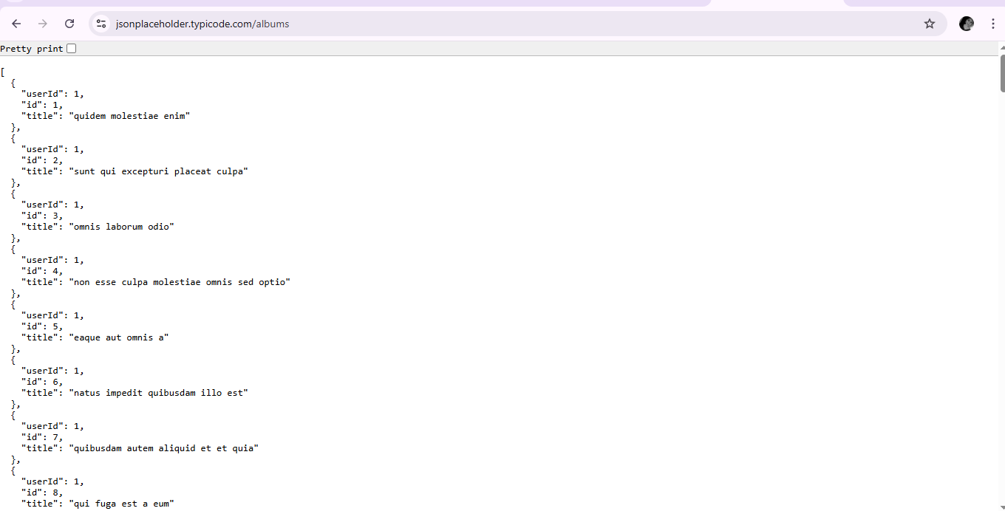Figure 4: /albums API response showing public access (optional).

9. Appendix / References
- JSONPlaceholder API Documentation: https://jsonplaceholder.typicode.com
- OWASP API Security Top 10: https://github.com/OWASP/API-Security

